TOWN OF ATHELSTANE
ORDINANCE ESTABLISHING SPECIAL OR SEASONAL WEIGHT
LIMITS
ORDINANCE
The Town Board of Athelstane, Marinette County, Wisconsin does hereby ordain as follows:
This ordinance, adopted by a majority of the town board on a roll call vote with a quorum present and voting and proper notice having been given establishes special or seasonal weight limits as follows:
- The following special or seasonal weight limits shall be effective for the periods stated below on the Town of Athelstane town highways.
- The town chairperson, or his or her designee, shall erect signs are required under s 349.16(2). Wis Stats, on or before the effective date of this ordinance.
- No person may operate any vehicle on any Town of Athelstane highway in violation of the above noted weight limits without a written permit issued by the Town Board of the Town of Athelstane. Upon conviction for a violation of this ordinance, the violator shall pay a of not less than $500.00 nor more than $19000.00, plus the applicable surcharges, assessments and costs for each violation. Each trip in violation of this ordinance constitutes a separate offense. In addition, the town board may seek injunctive relief from a court of record to enjoin further violations.
- Vehicles involved in the following designated activities are exempt from reduced weigh restrictions:
  - Perishable food haulers
  - School buses
  - Emergency vehicles
  - Waste haulers for township garbage collection
  - Town vehicles
  - Propane/Fuel oil home delivery trucks (at 50⁰ 0 capacity)
  - Any vehicle issued an "Overweight Permit" by the Town of Athelstane
- Seasonal weight restrictions in the Town of Athelstane will remain in effect 2 (two) weeks after the bans are lifted by Marinette County

SEVERABILITY
In the event that any section or sections herein shall be ruled unconstitutional by any competent court, such determination shall not affect the validity or effectiveness of the others sections of this Ordinance and the remainder of said Ordinance shall remain in effect.
1
TOWN OF ATHELSTANE
MARINETTE COUNTY, WISCONSIN
ORDINANCE NO. 26: ORDINANCE ESTABLISHING SPECIAL OR SEASONAL WEIGHT LIMITS

The Town Board of the Town of Athelstane does hereby amend the Town of Athelstane ORDINANCE ESTABLISHING SPECIAL OR SEASONAL WEIGHT LIMITS ordinance and does ordain as follows:
Add E: Seasonal weight restrictions in the Town of Athelstane will remain in effect for 2 (two) weeks after the bans are lifted by Marinette County.
The above amendment was adopted by a quorum of the town board at a properly noticed town board meeting on the 12th day of March, 2024
The Town Board of the Town of Athelstane
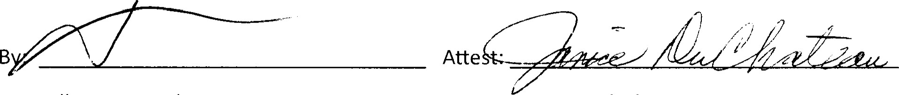
Kelly Barnes, Chairman Clerk
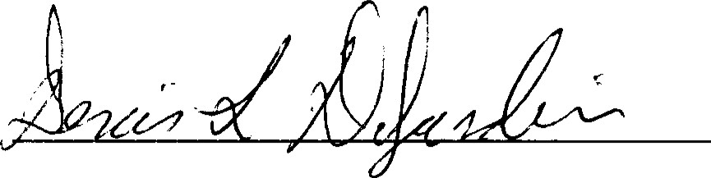
Denis DeJardin, Supervisor I
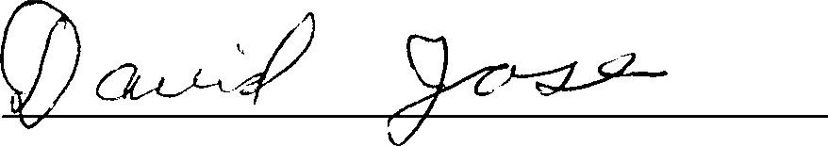
David Jose, Supervisor Il

