TOWN OF ATHELSTANE
SNOWMOBILE ROUTE ORDINANCE ORDINANCE #21

SECTION 1 - TITLE AND PURPOSE
The title of this ordinance is the Town of Athelstane Snowmobile Route Ordinance. The purpose of this ordinance is to establish snowmobile routes in the town and to regulate the operation of snowmobiles in the town.

SECTION 11- AUTHORITY
The town board has a specific authority to adopt this Snowmobile Route Ordinance under s. 350.18, Wis. Stats

SECTION 111 - ADOPTION OF ORDINANCE
This Ordinance, adopted by a majority of the town board on a roll call vote with a quorum present a voting and proper notice having to be given, designates snowmobile routes to the town and provides for the regulation of the use of those trails.

SECTION IV - DESIGNATION OF SNOWMOBILE ROUTES
The following roads are designated snowmobile routes in the town:
- Benson Lake Road from Mathis Road to Silver Cliff town line
- Eagle River Road from Northway Drive to Near North Trail Riders Park and Ride and from 250 feet East of Tower Road to 1625 feet West of Tower Road
- Firelane Road from one mile north of County Road C to south end
- King Street from Northway Drive to 350 feet west
- Newton Lake Road from Stephenson town line to 1200 feet north
- Northway Drive from County Road C to Eagle River Road
- Old County Road "A" from Benson Lake Road to Dunbar town line
- Thompson Road from Forest Road 207 to Forest Road 208
- White Lane from Benson Lake Road to north end
- Newton Lake Road from Lakeside Lane to 1.24 miles north

SECTION V - CONDITIONS APPLICABLE TO SNOWMOBILE ROUTES
The following restrictions are placed on the use of the town snowmobile routes designated by this resolution during the following periods of the year:
- Town highways designated as snowmobile routes shall be marked with uniform snowmobile route signs in accordance with s.350.13, Wis. Stats.
- Operation shall be subject to all provisions of s.350.04(2), Wis. Stats. , and any other provision of chapter 350, Wis Stats., which is adopted as a part of this ordinance by reference, pursuant to s.350.18, Wis. Stats.
- A copy of this ordinance shall be sent by the town clerk to the Marinette County Sheriffs Department.

SECTION VI - ENFORCEMENT
This ordinance may be enforced by any law enforcement officer authorized to enforce the laws of the State of Wisconsin.
SECTION VI - PENALTIES
The penalties under s. 350.11, Wis. Stats., are adopted and incorporated by reference.

SEVERABILITY
In the event that any section or sections herein shall be ruled unconstitutional by any competent court, such determination shall not affect the validity or effectiveness of the others sections of this Ordinance and the remainder of said Ordinance shall remain in effect.
This ordinance adopted by the Town Board of the Town of Athelstane on this 9th day of February,•2016.
The Town Board of Athelstane
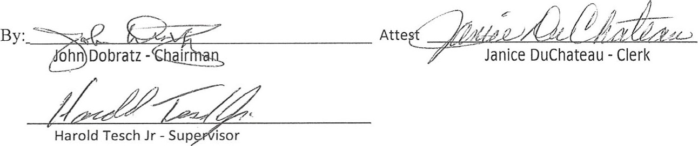
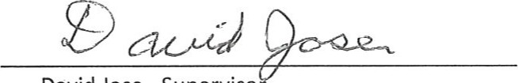
David Jose - Supervisot
TOWN OF ATHELSTANE MARINETTE COUNTY, WISCONSIN

ORDINANCE # 21: SNOWMOBILE ROUTE ORDINANCE
The Town Board of the Town of Athelstane does hereby amend the Town of Athelstane ordinance and does ordain as follows:
Amend Section IV: DESIGNATION OF SNOWMOBILE ROUTES

Amend to add i: Newton Lake Road from Lakeside Lane to 1.24 miles north
The above amendment was adopted by a quorum of the Town Board of Athelstane at a properly noticed town board meeting on the 14th day of October, 2025.
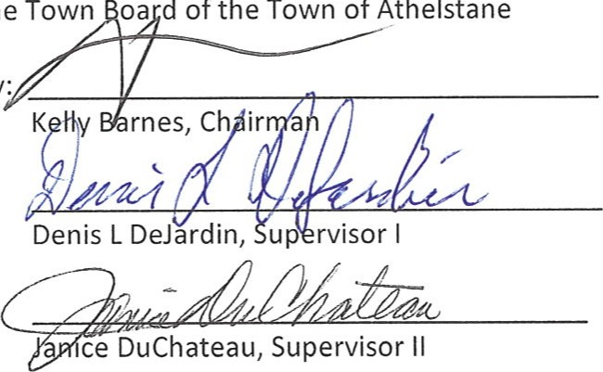
By: Atte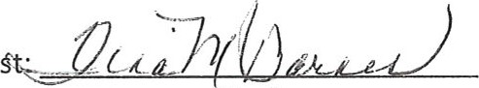
The
Town
oa
d
of
the
Town
of
Athelstane
Clerk

