TOWN OF ATHELSTANE
ROAD DEBRIS
ORDINANCE
The Town Board of Athelstane, Marinette County, Wisconsin, does hereby ordain as follow:

SECTION 1 - DEFINITIONS
For the purposes of this Ordinance, the following definitions shall be used. Words used in the present tense include the future; the singular number includes the plural number and the plural number includes the singular number. The word shall is mandatory.
- Debris. Any foreign material including but not limited to snow, leaves and brush.
- Town Roads. Any traveled roadway maintained by the Town of Athelstane or used by the public within the Town of Athelstane.
- Traveled Roadway. The entire driving surface including the shoulders.

SECTION 2 - GENERAL PROVISIONS
A. The practice of leaving any debris on Town Roads is prohibited. Any debris left on Town Roads creates a hazard for the public and creates a problem for our road maintenance operations. In some cases, it may cause the person responsible to be held liable for personal injuries or property damage.

SECTION 3 - PENALTIES
Any person not in compliance shall be adjudged a forfeiture of fifty ($50.00) dollars for each offense, plus those costs of prosecution permitted by Wisconsin statutes. Each day that an individual is in violation of this Ordinance shall be considered a separate violation for which a separate penalty may be applied.

SEVERABILITY
In the event that any section or sections herein shall be ruled unconstitutional by any competent court, such determination shall not affect the validity or of the others sections of this Ordinance and the remainder of said Ordinance shall remain in effect.
This ordinance adopted by the Town Board of the Town of Athelstane on this 1 1 ^{th} day of February, 2020.
The Town Board of Athelstane
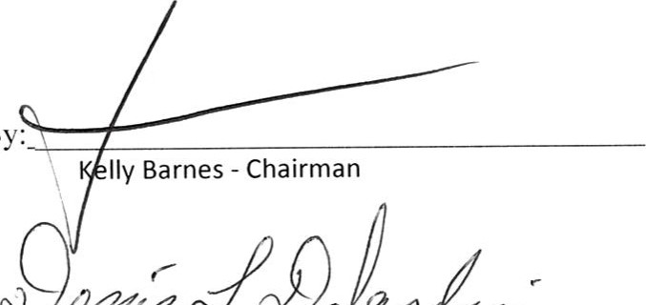 Attest 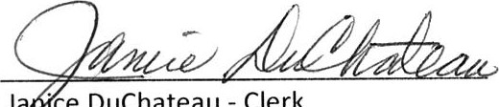
By:
Ja
•ce
DuChateau
-
Clerk
Denis DeJardin - Su | isor
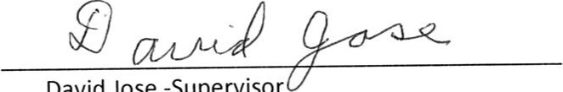
David
Jose
-Supervisor

