TOWN OF ATHELSTANE
ALTERNATE FOR BOARD OF REVIEW
ORDINANCE
The Town of Athelstane, Marinette County, Wisconsin does hereby ordain as follows;

SECTION 1: TITLE AND PURPOSE
The Title of this Ordinance is the Town of Athelstane appoint alternate members to the Board of Review. The purpose of this Ordinance is to authorize the Town Board of the Town of Athelstane, to appoint alternate members to the Board of Review.

SECTION 2: STATUTORY AUTHORITY
Pursuant to Wis Stat SS70.47(6m)(c) and 70.46(1 ) the Town of Athelstane Board is authorized to make the appointment of alternate members to serve on the Athelstane Board of Review when standing members are removed from individual cases or unable to serve for any reason.

SECTION 3: ADOPTION OF ORDINANCE
This Ordinance, adopted by a majority of the town board on a roll call vote within a quorum present and voting and proper notice having been given, provides the authority for the town to appoint alternates to the Board of Review.
SECTION 4: APPOINTMENT
The following electors of the Town of Athelstane are hereby named as alternates to serve as alternate Board of Review members:
- Gary Welsch
- Edie Boesen
- Jill LaCount
The alternate member shall be drawn at random from the above list.

SECTION 5: EFFECTIVE DATE
The appointments made in this ordinance are for the year 2025 Board of Review proceedings and succeeding years until such appointments are rescinded by action of the town board and effective upon posting as provided by law.
This ordinance adopted by the Town Board of the Town of Athelstane on this 1 I ^{th} day of February, 2025.
The Town Board of Athelstane
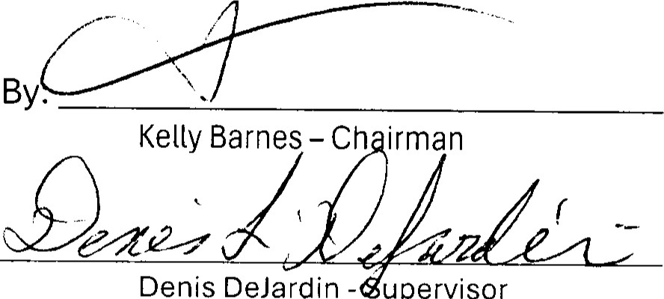
AtteSt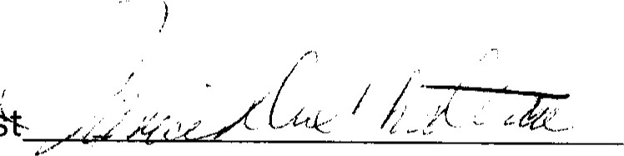
Denis
DeJardin
upervisor
Janice DuChateau - Clerk
